- Midterm Reflection
Working on this midterm was actually a good chance for me to get more comfortable with basic network programming. Before starting, I had seen socket examples in tutorials, but I had never built a full client–server setup from scratch. So my first step was simply breaking the assignment into small pieces: first make the server listen, then get the client to connect, then figure out how to send and receive messages without the program freezing or crashing.
For part-1 I used “python theServer.py --host 127.0.0.1 --port 9000 “ to have my cmd as server. Then I opened another cmd and had it as client by typing “python theClient.py --host 127.0.0.1 --port 9000”. Then we checked if the message goes from client to the server by typing “Hello. This is Mike” from client and saw that message is taken from the server.
At first, the socket connection part looked simple, but I ran into a few issues. For example, I mixed up when to close the connection on both sides. If the client closed too early, the server would throw an exception. I fixed this by adding try/except blocks and making sure the server loop kept running even after errors. I did use an AI tool a few times—mostly to ask specific questions like “why is my socket stuck in TIME_WAIT?” or “what is the proper way to close a socket?” These were more like debugging hints. In every case I rewrote the code manually because I wanted to understand what each line was doing.

The port scanner was a bigger challenge. My first version scanned ports one by one with no timeout, which made the scan extremely slow. I eventually realized that every connection attempt needs a short timeout to avoid hanging. I also added small delays so the code wouldn’t look suspicious or aggressive. (I set the delay to 0.005. before adding that it seemed stuck.) One of the AI prompts I used was something like: “How should I structure error handling when scanning invalid ports?” The suggested code was very long and complicated, so I simplified it heavily and only kept the parts that made sense to me, like checking if the port is between 1 and 65535. I also rewrote several parts to match my own style with clearer variable names.

A big part of this assignment was thinking about the ethical side. Writing a port scanner feels powerful, but I see now why legality matters. Even scanning a random website without permission can be considered unauthorized access. The assignment rules (only localhost and scanme.nmap.org) made sense.

Overall, this midterm helped me understand how security automation tools are built at a low level. Even something simple like checking which ports are open becomes much clearer when you write the scanning logic yourself. I feel more confident now using network sockets, debugging connection issues, and thinking about security responsibilities as a developer. Writing everything out and testing both the successful and failing cases also helped reinforce the ideas much more than just reading theory.
- Github Repository Link: https://github.com/ClaptainCheeks/midterm
- Screenshots For Part-1

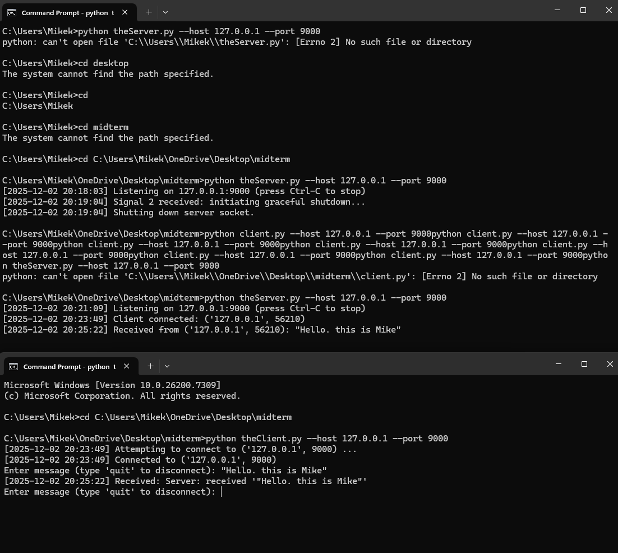
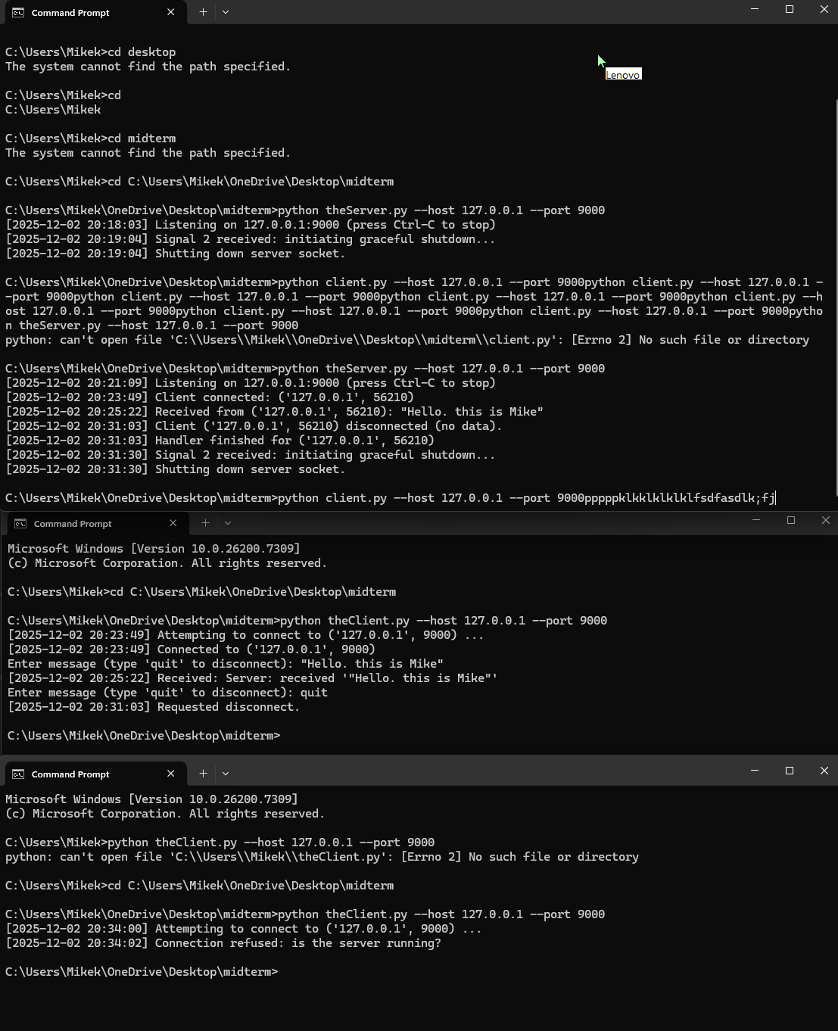

- Screenshots for Part-2
